March 28, 2023 – Java Project – Thea Gregory 5291240

Today I worked on the following:

* Created tables for OrderInfo, Deliveries, and Order in the mysql db and implemented corresponding foreign keys
* Worked on the controller for create order
* Made the view for add delivery guy

I touched a lot of different things today, and that pushed my progress along nicely. I am now more confident that I can finish the project on time, as there is not much left to do after Delivery guy is completed other than a few minor views and queries. The challenging elements of making the logic are mostly completed and now it’s mostly just repetition of things I’ve already accomplished. I had some trouble setting up my foreign keys because I forgot to set one table to InnoDB, but I was able to correct the issue and finish the task. This afternoon I will finish off Delivery guy and then start pushing out the Order History and the Manager/Restauranteur sections.

**Screenshots**:

Order Table from db:

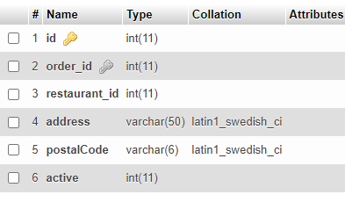

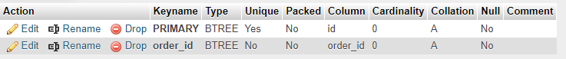

Orders Table:

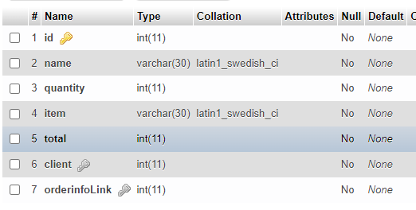

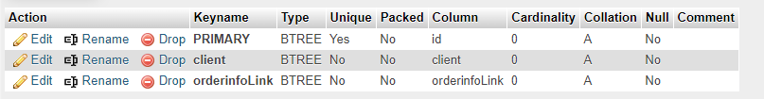

Create Order (work in progress):

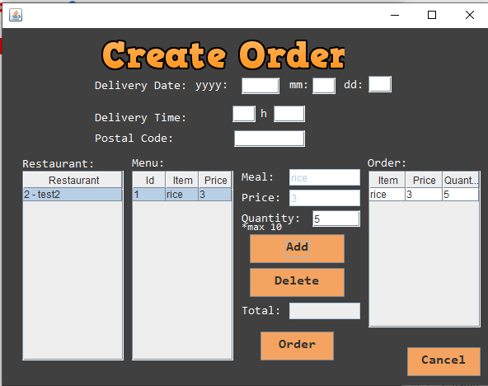

Beginnings of the View for Create Delivery Driver:

